Windows CE Installation Guide
1 Welcome to the Windows CE Installation Guide
The purpose of this MANUAL is to provide users of USB 2.0 To RS232 with a simple procedure for installing drivers for their devices on PDAs and targets running Windows CE 4.2 and later.
2 Installing Devices
The VCP drivers emulate a standard COM port. These can be communicated with in the same manner as any other COM port on the PC.
• ftdi_ser.dll - the VCP driver file
• FTDIPORT.inf - user changeable file to allow devices with custom VID and PID combinations to be installed
• Copy all of the unzipped files to the \\Windows directory on the PDA.
• If the PDA requires a host adaptor (e.g. USB host cable, presentation pack or Compact Flash host card), make sure that it is connected and installed before proceeding.
• Connect the RS232 device to a host USB port on the PDA. This will provide a dialog box to direct Windows CE to the driver files.
• Type the full name of the VCP driver file into the dialog box as shown below. If the file name is incorrect, the driver will not be found and the device will not function.
• The device installation is now complete.
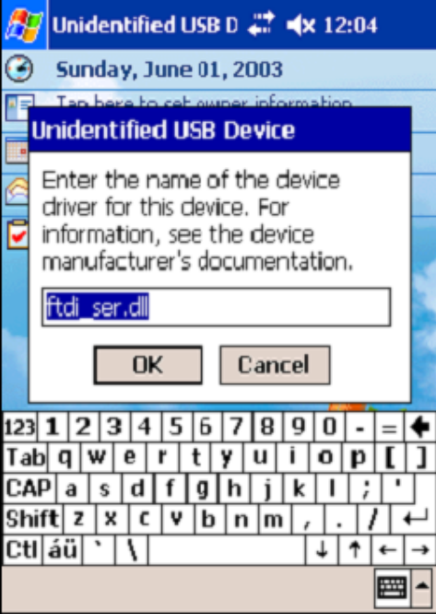
• The device installation is now complete.

